
Kew High School
Year 7 Science CAT 2
2020

Ecosystem Presentation Task
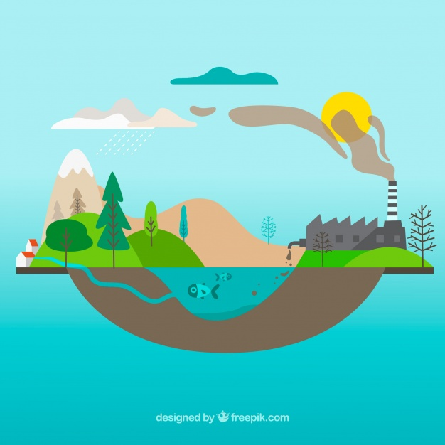

Emerging
Working Towards the Standard
At the Standard
Above the Standard
Well Above the Standard

Task
For this task, you are to conduct a wide-ranging research project about a habitat/ecosystem of your choice. The project will incorporate three different parts. At the end of your research, you will be delivering an oral presentation about your findings to the class.
The format of your presentation can include, but not limited to:
- Power point
- Prezi (https://prezi.com/)
- Canva (https://www.canva.com/)
- Website (https://www.wix.com/ , https://www.weebly.com/au )
- Scientific poster (Templates can be downloaded from https://www.makesigns.com/SciPosters_Templates.aspx)
The Power Point template is available on Compass. The template is there to provide you guidance. You are encouraged to utilise your creativity to deliver your presentation in however you like.

Part A – Habitat/Ecosystem Analysis

In this section you are to choose a habitat or ecosystem from the list below. As part of your analysis you will need to include the following sections:
- Biotic factors
- Abiotic factors
- Examples of symbiotic relationship present in chosen ecosystem
- Levels of ecological organisation
- Picture/pictures of your chosen habitat/ecosystem
- List of examples of organisms within the habitat/ecosystem.

Examples of Ecosystems / Habitats

- Tropical Rainforest
- Temperate Forest
- Grasslands
- Desert
- Tundra
- River and Streams
- Coral reefs
- Lakes

Part B – Food Web

In this section you will need to identify a mixture of organisms within your chosen ecosystem and construct a food web.
Your food web needs to include:
- At least two producers and 6 other organisms.
- Clearly labelled trophic levels.
- A description of how energy moves through an ecosystem.

Part C – Human Impacts

In this section you are to identify a human impact that is specific to your chosen ecosystem.
Examples include (but not limited to):

- Land clearance
- Air pollution
- Mining
- Water pollution
- Farming practices
- Bushfire
- Light pollution
- Noise pollution

You will need to answer the following questions:
- How does your chosen human impact negatively affect the ecosystem? Consider the food webs or abiotic factors that may be affected.
  - What are the short-term effects on the ecosystem?
  - What are the long-term effects on the ecosystem?

- Predict the effects of the human impact on the ecosystem if nothing is done to address it.

- Choose a specific example of organisms in your chosen ecosystem. Describe how your chosen human impact may influence their life.

